**IEC Electricity Meters**

Residential

**DDSF198**

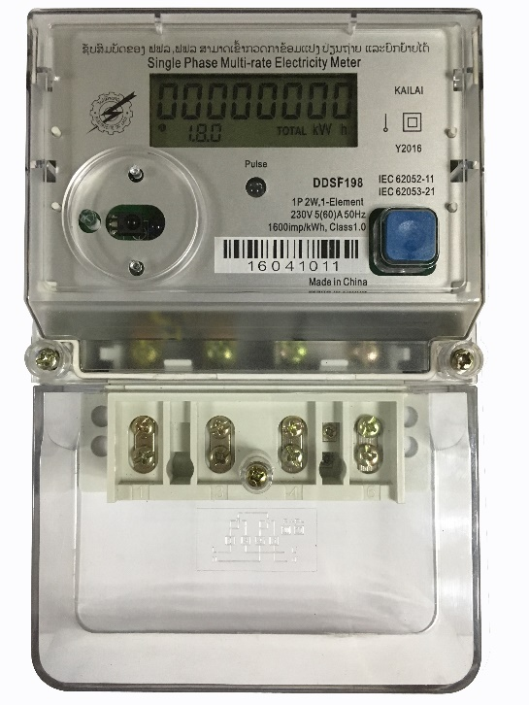

Single-phase, Multi-functional Electronic electricity meter

* Cost-effective meter
* Easy integration into existing and future reading systems
* Reduced data collection cost because of high data transmission rate
* Less regular intervals necessary to synchronize device clock
* Easy installation

**Technical Parameter:**

Type: DDSF198

Connection：1Phase 2 Wire

Rated Current：5/60A

Rated Voltage：230 V

Voltage Range：75%Un ～ 120%Un

Frequency：50 Hz

Accuracy Active：1.0

Operating Temperature：-30℃～+55℃

Operating Temperature：-40℃～+70℃

Relative Humidity：≥ 95% no condensing

**Overview**

DDSF198 the latest generation of electronic energy meter designed for residential applications.

The meter with internal real-time clock is a compact meter offering cost-effective, complex tariff functionality with enhanced features. An integrated, flexible programmable management capacity gives full Time Of Use (TOU) metering, eliminating the need for an external timing device.

With a modern design and 10year certification life, the small and compact DDSF198 meter offers significant additionaloperational benefits over existing meter types.

**Backup power supply**

Meter is equipped with lithium battery as backup power supply during power off to maintain real time clock and LCD display.

**LCD Display**

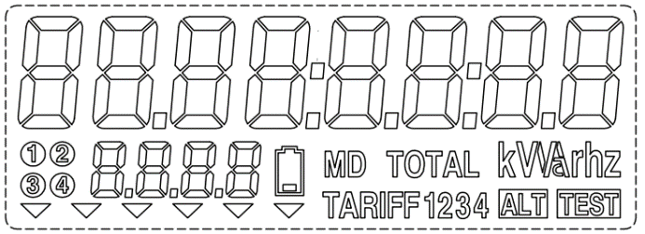

Full segment display

After power up, meter will show full segment display for 3 seconds then switch to auto scroll mode.

**Auto scroll mode:**

Meter display following items with 5 seconds interval.

|  |  |  |  |  |
| --- | --- | --- | --- | --- |
| **Item** | **OBIS** | **Description** | **Data format** | **Unit** |
| 1 | 1.8.0.0 | Total active energy(+) of previous 1 month | XXXXXXXX | kWh |
| 2 | 1.8.0 | Total active energy(+) of current month | XXXXXXXX | kWh |

**Push button mode**

By push button, meter will enter into pushbutton display mode and switch display of the following items.

|  |  |  |  |  |
| --- | --- | --- | --- | --- |
| **Item** | **OBIS** | **Description** | **Data format** | **Unit** |
| 1 | 0.9.2 | Date | DD.MM.YY |  |
| 2 | 0.9.1 | Time | Hh:mm:ss |  |
| 3 | 31.7.0 | Current | XXX.XXX | A |
| 4 | 32.7.0 | Voltage | xxx.x | V |
| 5 | 1.8.0.0 | Total active energy(+) of previous 1 month | XXXXXXXX | kWh |
| 6 | 1.8.0 | Total active energy(+) of current month | XXXXXXXX | kWh |
| 7 | 13.7.0 | Power factor | X.XXX |  |

**Display during power off**

Meter switch of the display during power off to save battery life.

After push button the LCD display could be activated and display the following items. Without any operation for 30 seconds, the LCD display will be switched off again.

|  |  |  |  |  |
| --- | --- | --- | --- | --- |
| **Item** | **OBIS** | **Description** | **Data format** | **Unit** |
| 1 | 1.8.0.0 | Total active energy(+) of previous 1 month | XXXXXXXX | kWh |
| 2 | 1.8.0 | Total active energy(+) of current month | XXXXXXXX | kWh |

**LED pulsing output**

Meter is equipped with one LED pulse output.

**Backlight**

Meter is equipped with blue display backlight, the backlight will light up for 30 seconds then switched off. It can be activated at any time by push the pushbutton.

**Communication port**

Meter is equipped with one far inferred port for meter reading thru HHU and another RS485 port for remote meter reading.

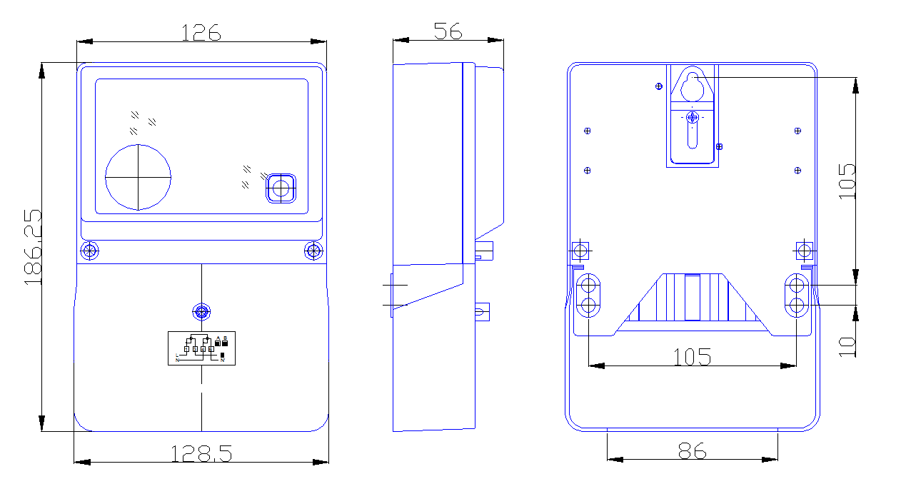

Meter external dimensions (unit: mm)

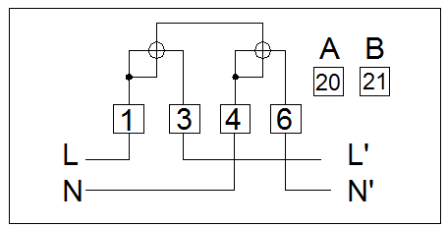

Meter Connection Diagram

Yue Qing kailai meter co., Ltd.

Caotianhou Industry, Liushi town, Yueqing city, Zhejiang Province, China

<Tel:+86-577-62672501> Fax: +86-577-62678998